Meiosis Worksheet
This worksheet accompanies the What happens during meiosis? animation.

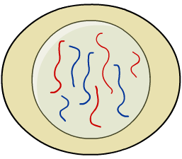
1. Scientists discover a new species of animal.
It has eight chromosomes in each body cell and
reproduces sexually. One of its body cells is
shown in the diagram:

a) What is the diploid number for this animal?

………………………………………………………

b) What is the haploid number for this animal?

…………………………………………………………

c) How many sets of chromosomes will be found in one of its gametes?

………………………………………………………………………………………………………

The animal produces gametes by the process of meiosis.
The diagrams below show the process.

d) Draw in the missing chromosomes at each stage using the information from
the boxes.

Stage 1 Stage 2
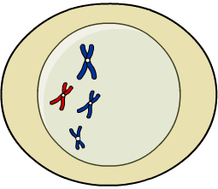
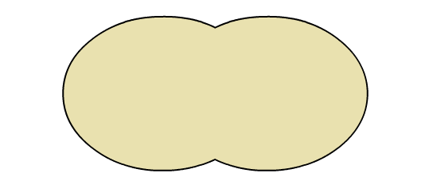

The chromosomes make an exact copy  of themselves. | The chromosomes split up into two cells.  Each cell has one of each pair of  homologous chromosomes.
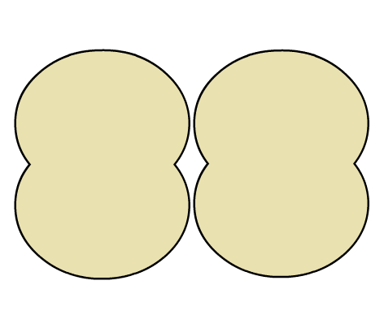
Stage 3 Stage 4

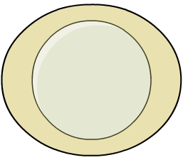

The chromosomes are then pulled apart to form four cells. | Each sex cell produced has half of the original number of chromosomes.

e) Why is it important for the number of chromosomes in a sex cell to be half that of a normal body cell?

……………………………………………………………………………………………………………
……………………………………………………………………………………………………………
……………………………………………………………………………………………………………

2. Variations occur during sexual reproduction. This variation is important to the process of evolution. Explain how variation occurs during meiosis and fertilization.

…………………………………………………………………………………………………………

…………………………………………………………………………………………………………

…………………………………………………………………………………………………………

…………………………………………………………………………………………………………

…………………………………………………………………………………………………………

…………………………………………………………………………………………………………

…………………………………………………………………………………………………………

